**Introduction**

Mental health awareness has become crucial in today’s fast-paced world. To bridge the gap between emotional support and accessibility, I developed an **AI-powered Mental Health Chatbot**. This chatbot provides immediate, judgment-free interactions to users experiencing stress, anxiety, or loneliness, leveraging natural language processing (NLP) to deliver empathetic responses.

**Abstract**

The chatbot uses **Hugging Face’s DialoGPT-small**, a pre-trained conversational AI model, fine-tuned for mental health support. Built with **Python, Flask, and Transformers**, it features:

* **Keyword-based empathy triggers** (e.g., "sad," "anxious")
* **Conversation logging** for user privacy
* **Simple web interface** for universal access

Designed for **low-resource environments**, it runs efficiently on CPU and requires minimal setup.

**Tools Used**

* **Backend -** Python 3.8+, Flask, Hugging Face Transformers, Torch
* **Frontend -** HTML/CSS, JavaScript
* **Development** - VS Code, Git, Virtual Environments
* **Deployment -** Render/Replit (Optional)

**Steps**

* **Phase 1 - setup**
* **Created virtual environment -** python -m venv venv
* **Installed dependencies -** pip install flask transformers torch
* **Phase 2 – Backend Development**
* Implemented Flask API with routes for chat interactions.
* Integrated DialoGPT-small for dynamic responses.
* Added mental health keyword detection (e.g., "stress" → empathetic response)
* **Phase 3: Frontend Development**
* Built a responsive UI with message history.
* Added JavaScript fetch calls to the Flask backend.
* **Phase 4: Testing & Debugging**
* Tested edge cases (short inputs, offensive language).
* Fixed Torch installation issues by using CPU-only version.

**Conclusion**

This project demonstrates how AI can democratize mental health support with minimal resources. While not a substitute for professional therapy, the chatbot offers immediate, stigma-free interactions. Future enhancements could include:

* Multilingual support
* Crisis resource integration (e.g., helpline numbers)
* Sentiment analysis for better response personalization

**Prototype**

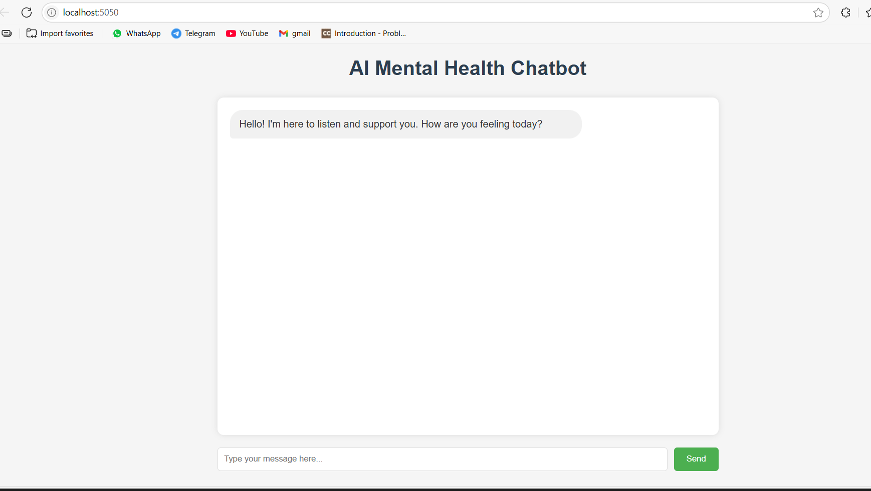

<https://github.com/Milind-1/AIML-Final-projects-Milind-Shrivastava.git>

**Prepared by**: Milind Shrivastava

**Date**: 28/07/2025